**\*\*Developed By Sanchit Bhise\*\***

**Instructions**

- Install the Requirements: pip install -r requirements.txt

- Then, make database migrations: python manage.py makemigrations

- python manage.py migrate

- And finally, run the application: python manage.py runserver

**Let’s explore the Project**

**1)Home**

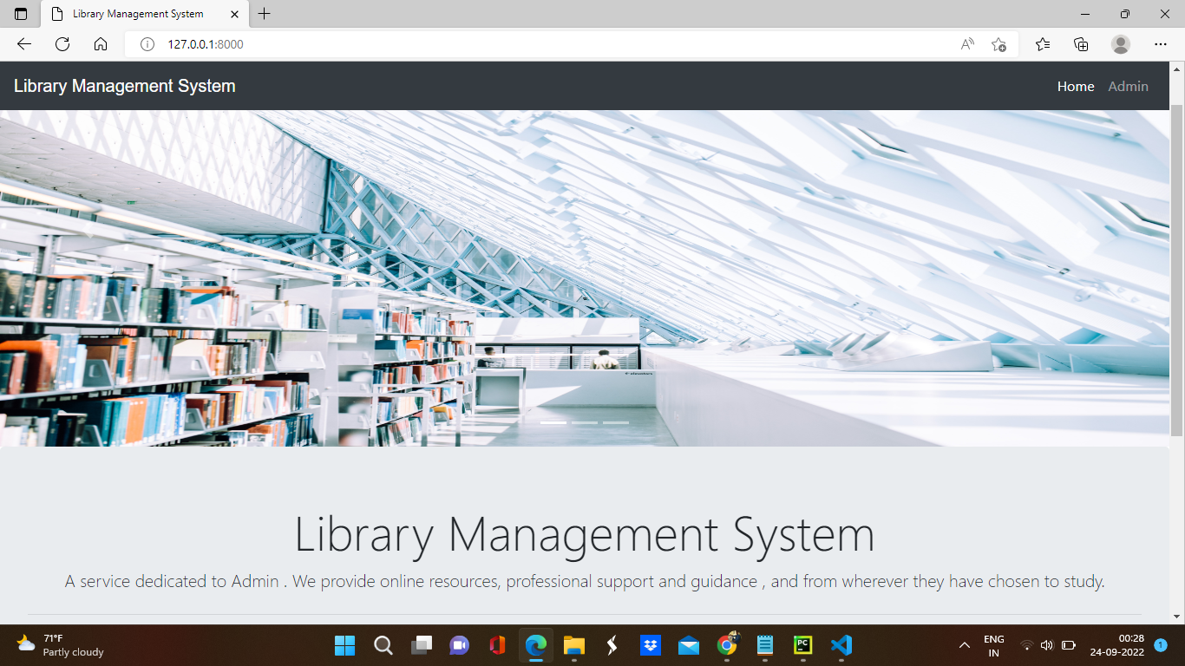

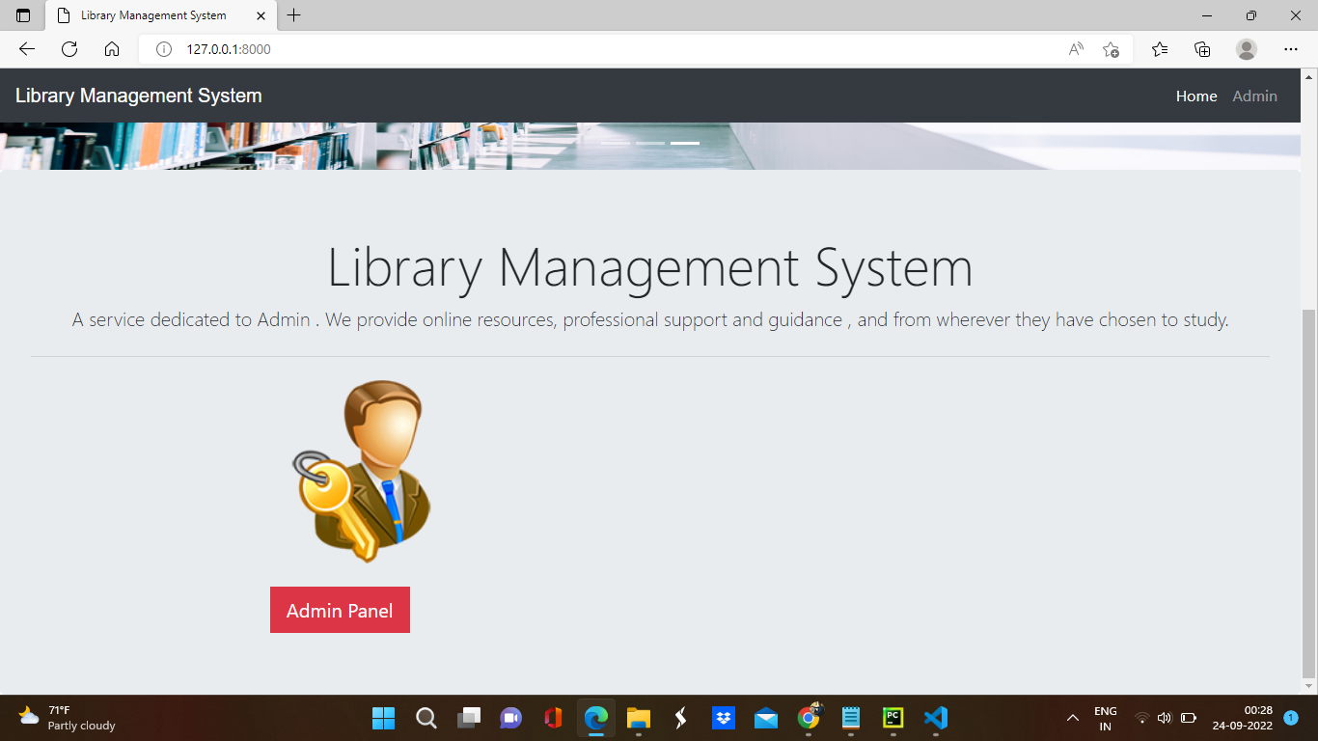

**2)Admin signup**

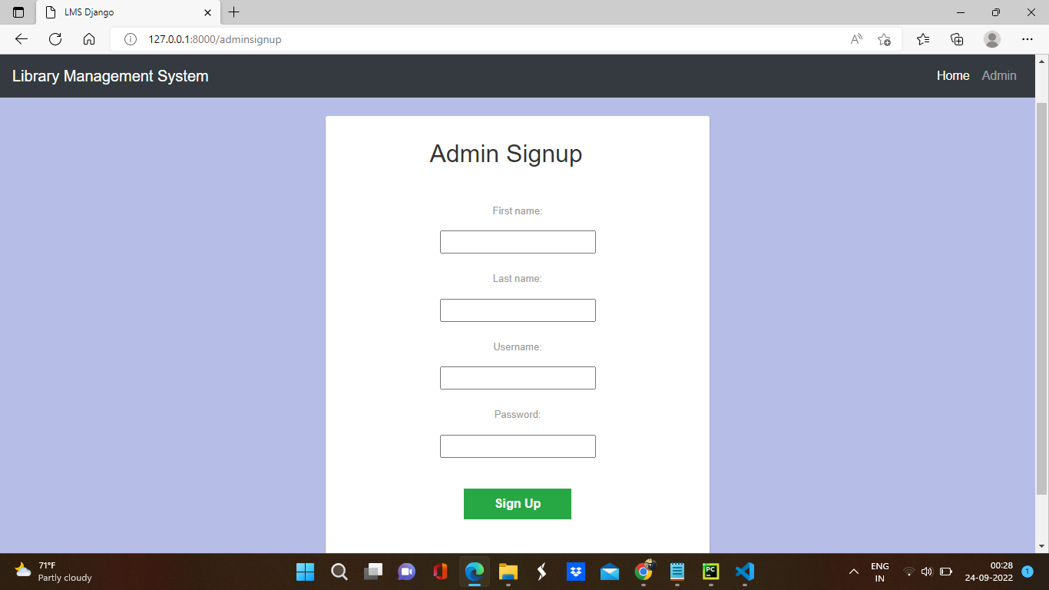

**3)Admin login**

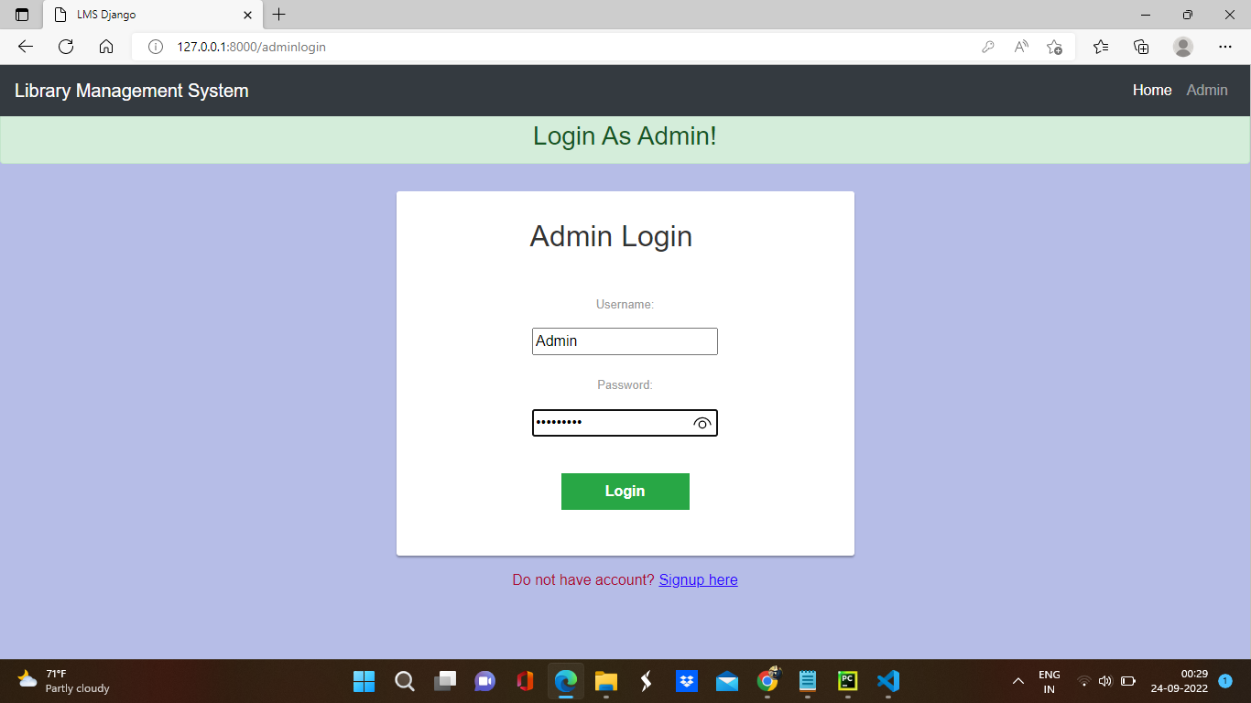

**4)Add book**

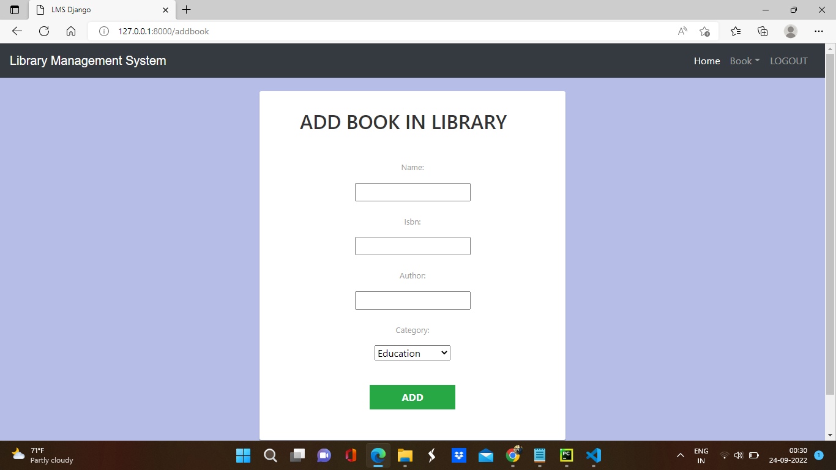

**5)View the List of Books**

